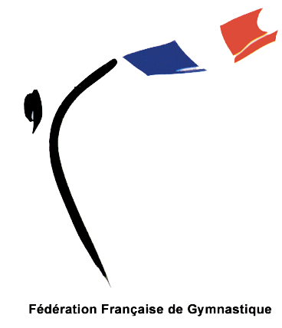

16th FRENCH AEROBIC GYMNASTIC OPEN
2nd – 7th May 2011, Arques, France

FORM Music Release

Form to be sent to: Deadline: 2th April 2012

Organizing Committee
AMGA
• Phone: +(33) 3 21 39 66 52 • Fax: +(33) 3 21 38 52 91
Complexe Gymnique
78 Avenue Pierre Mendes France
62150 ARQUES
Email : amga2@wanadoo.fr

Federation
Contact Person | Mr./Ms. | Last name: |  | First name:
Address | Address:
Address | ZIP/Postcode: |  |  | Country:
phone / Fax | Telephone: |  | Mobile: | Fax:
E-mail

Please describe the music you will use for the French Aerobic Gymnastic Open.

□ Originally-produced music

□ Existing music that I have recorded

Music Length: min. sec.

All songs used must be clearly specified below. Failure to disclose accurate information may result in financial liability and disqualification.( if you use more than two songs, please use the reverse side.)

Music title: Music title:

Artist: Artist:

Recording company: Recording company:

Regarding MUSIC COPYRIGHT, I understand that I am personally responsible for the selection of my music and for any copyright implications. I also understand that the FIG/FFG cannot guarantee that my music tape/CD, as I have prepared, will be broadcast. The FIG/FFG reserves the right to substitute my music at any time as necessary. By signing this document, I agree that the FIG/FFG reserves the right to broadcast my music, my performance, and appearance in any program or other broadcast related to the championship without any type of payment or compensation to me, of any kind. Nor does the FIG/FFG require my permission to broadcast or utilize my image in any such program or related promotion. I understand that if I falsify this document in anyway or fail to fill it out in its entirety, I risk being either penalized or disqualified.

I have carefully read, understand, and hereby agree to comply with the above:

Category: AGE GROUP 1: [ ] IM [ ] IW [ ] MP [ ] TR [ ] GR

AGE GROUP 2: [ ] IM [ ] IW [ ] MP [ ] TR [ ] GR

SENIOR: [ ] IM [ ] IW [ ] MP [ ] TR [ ] GR

AEROSTEP [ ] TEAM

AERODANCE [ ] TEAM

Date :

Athletes’ Signature:

Athletes’ Signature:

Athletes’ Signature:

Athletes’ Signature:

Athletes’ Signature:

Athletes’ Signature:

Athletes’ Signature:

Athletes’ Signature:

Athletes’ Signature:

Athletes’ Signature:

